# To get the activity and PlanID follow the below procedure :

Go to FF - Click on the Order view -- >

Select the Order ID/ SOR ID in the select box.

Select the Task which you need to find the Activity & Plan ID

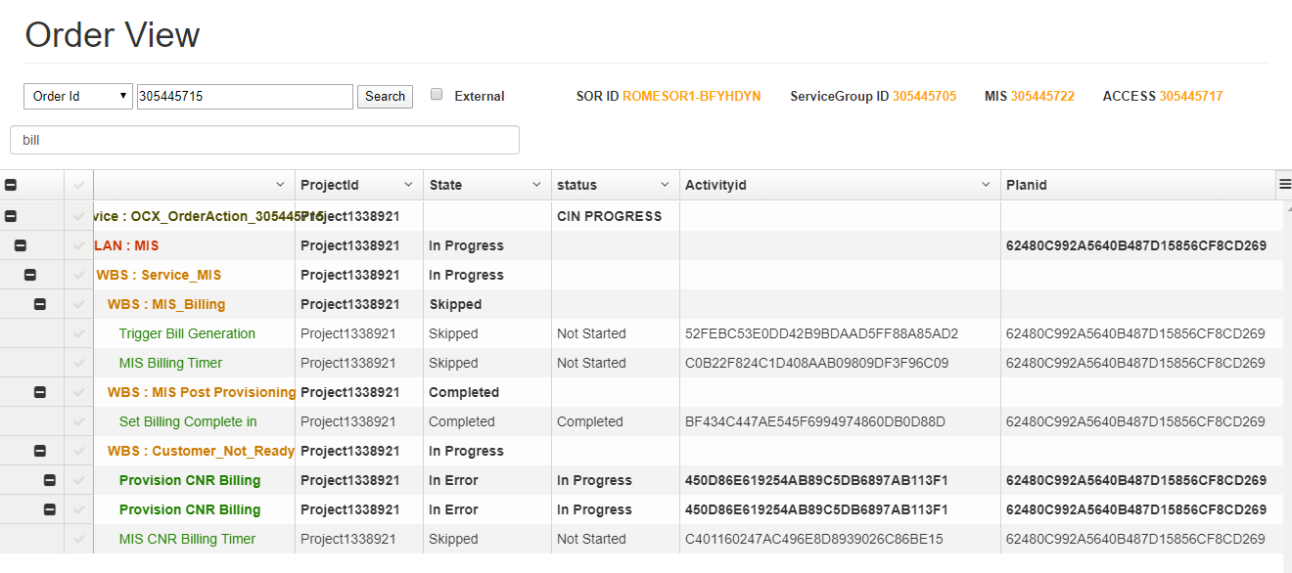

Get the Plan ID & activity ID

Project1338921

Activity ID -- C401160247AC496E8D8939026C86BE15

Plan ID - 62480C992A5640B487D15856CF8CD269